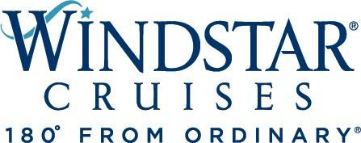

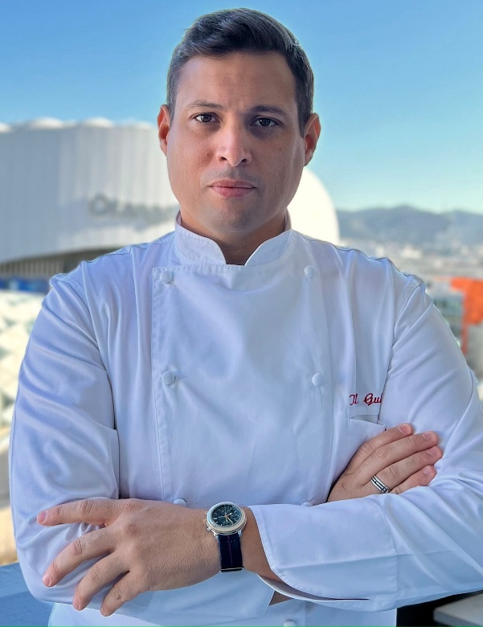
Executive Chef Karl Gulotta

Windstar Cruises Names Karl Gulotta Corporate Executive Chef
SEATTLE, WA, December 13, 2021 – U.S. headquartered Windstar Cruises has hired Karl Gulotta as its new corporate executive chef. The leading line in small ship cruises places a distinct emphasis on an elevated culinary experience and sources ingredients locally whenever possible.
The position directs Windstar’s onboard culinary operations department to achieve the highest levels of guest satisfaction and product consistency. Together with Windstar’s director of food and beverage operations, Gulotta will be instrumental in setting the tone, look, and feel of all culinary operations, ensuring they align with the company’s high standards, commitment to sustainable practices, devotion to regional menus and products, and its ongoing relationship as the Official Cruise Line of the James Beard Foundation.
Gulotta (who speaks English, French, and Spanish) is originally from Marseilles, France. He most recently worked with French cruise ship operator Ponant as executive chef, where he executed menus and recipes from acclaimed Chef Alain Ducasse. He previously held high-level culinary positions with Oceania Cruises, Disney Cruise Line, and a litany of land-based fine dining establishments (more than five with Michelin stars) located around the globe.
“We are excited to add Karl to our team of culinary professionals at Windstar,” said Vice President of Hotel Operations Stijn Creupelandt. “His breadth of proficiency both with cruise ships and some of the best restaurants on the planet will no doubt enhance our cruise guests’ experience.”
Gulotta will work aboard Windstar’s three Wind Class sailing ships and three all-suite Star Plus Class yachts deployed to destinations around the globe; and will work at times at Windstar’s Miami headquarters when the new office opens in 2022.
Windstar’s Beyond Ordinary Care health and safety program requires everyone aboard to be vaccinated, including crew. For more details on Windstar Cruises, visit www.windstarcruises.com.
Editor’s Note: A high resolution image of Gulotta is available here.
###
Contacts:
Sarah Scoltock, Director of Public Relations, Windstar Cruises / sarah.scoltock@windstarcruises.com
Sally Spaulding, Account Director, Percepture / sspaulding@percepture.com

About Windstar Cruises
Windstar Cruises operates a fleet of six boutique all-suite and sailing yachts carrying 148-342 guests. Small ship cruises sail throughout Europe, the Caribbean, Costa Rica and the Panama Canal, Asia, Alaska and British Columbia, Canada and New England, Tahiti and the South Pacific, Mexico and U.S. Coastal and Australia. Windstar launched the $250 Million Star Plus Initiative to transform the three all-suite Star Plus Class yachts with new suites, restaurants, and a world-class spa and fitness center. The award-winning line is known for immersive experiences, destination authenticity, port-intensive itineraries, exceptional service, and an innovative culinary program. Windstar Cruises is part of the Xanterra Travel Collection, a group of global hospitality and travel companies, one of which traces its history back over a hundred years of operating our country’s iconic national parks, including Grand Canyon, Yellowstone, Glacier, Death Valley, and many others. Xanterra Travel Collection is owned by The Anschutz Corporation, the ultimate owner of the Broadmoor, Sea Island, and entertainment giant AEG, Anschutz Entertainment Group.

